OPEN ENDED LAB

OBJECTIVE: To demonstrate the concepts of deadlock and synchronization in a concurrent system by simulating a smart traffic control scenario, and to understand how proper lock ordering can prevent deadlock and ensure safe resource sharing among multiple threads.
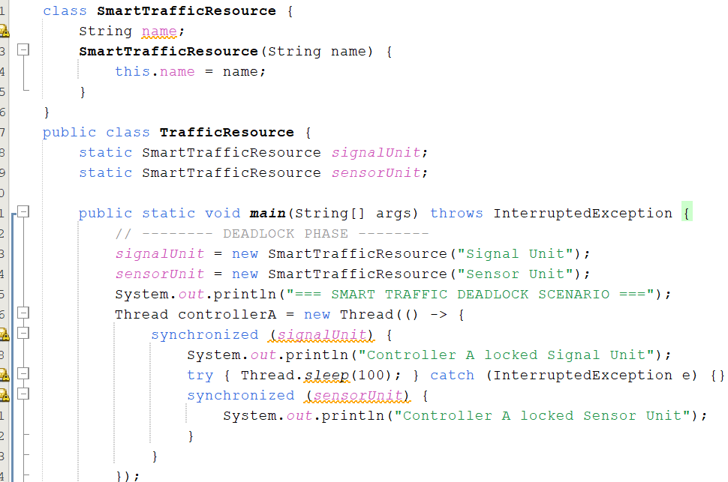

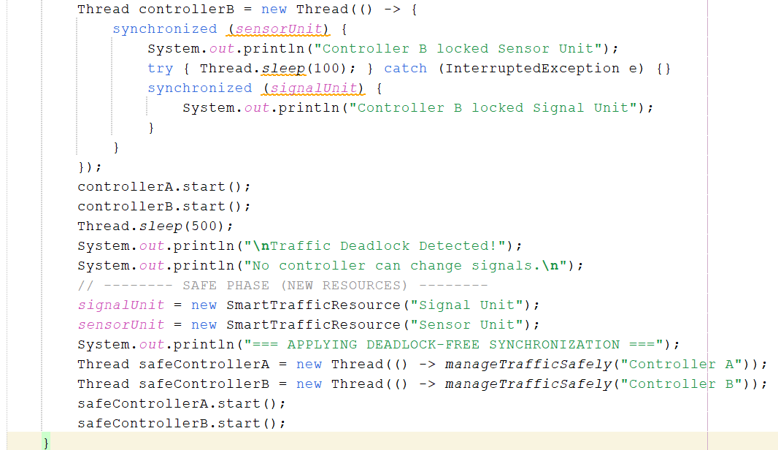

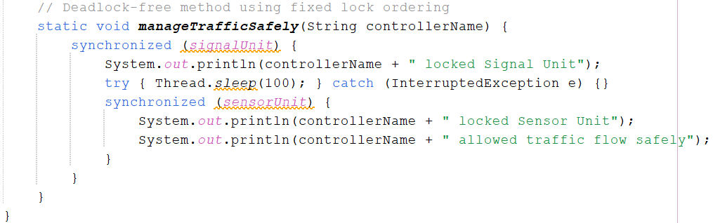

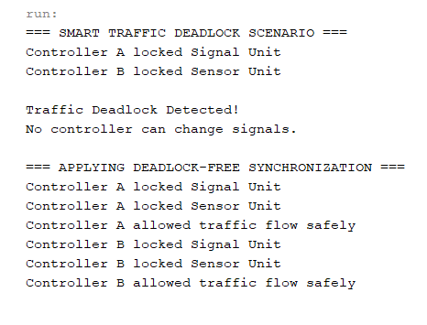
OUTPUT:

